Dynamic Angiogram Imaging (DAI) Vera
Software Architecture Document
Version 1.2

Revision History
Date | Version | Description | Author
13 April 2023 | Alpha 6.4 | Architecture Document for DAI Vera Software | Aaron So, Mahmud Hasan
06 May 2024 | Alpha 10.7 | Architecture Document for DAI Vera Software | Aaron So, Mahmud Hasan
11 Sept 2024 | Alpha 11.3 | Architecture Document for DAI Vera Software | Aaron So, Mahmud Hasan

Contents
1. Introduction 4
2. Purpose 4
3. Scope 4
4. Definition, Acronyms, Abbreviations 4
5. References 4
5.1 Scientific References: 4
5.2 Technical References: 5
6. Architectural Goals and Constraints 5
7. Use Cases 5
7.1. Curve Fitting: 5
7.2. Curve Loading: 6
7.3. Dicom Export: 6
7.4. Enhanced to Regular Dicom Conversion: 6
7.5. Dicom Interpolation: 6
7.6. Dicom Time Series Extraction: 7
7.7. FFR Calculation: 7
7.8. Drawing ROI: 7
7.9. Instantaneous Plot: 8
7.10. Point Removal: 10
7.11. Point Correction: 10
7.12. Report Generating: 10
7.13. Activity Tracking: 10
7.14. 4DCT Dicom Loading: 11
7.15. Enhanced Dicom Processing: 12
7.16. Siemens Half-and-Half Scan Dicom Processing: 13
7.17. Context Menu: 13
7.18. Time Info Extraction and Application: 14
7.19. Multi Stenosis Information Calculation: 15
7.20. Point Removal Function: 15
7.21. Clear Curve: 15
7.22. JSON Data: 16
7.23. 3D Volume (CTA) Loading: 16
7.24. Data Labelling: 16
7.25. Supervised Learning: 17
7.26. Screen Capturing: 18
7.27. Mode Changing: 19
7.28. Font Changing: 19
7.29. Option Changing: 20
7.30. Logging: 20
7.31. Removing Older Logs: 20
8. Logical View 21
9. Process View 21
9.1. User Activities: 22
9.2. Curve Fitting Activities: 22
9.3. FFR Calculation Activities: 22
9.4. Result Export Activities: 22
9.5. Supervised Learning Activities: 22
10. Workflow View 22
11. Deployment View 23
12. Size and Performance 23
12.1. Installer Size: 23
12.2. Memory Requirements: 23
13. System Compliance 23
14. Glossary 24
14.1. List of Input Parameters 24
14.2. List of Output Parameters 25
14.3. Definitions of terminologies 25

Introduction

This document provides an overview of the architecture of the software system defined as DAI Vera Alpha 11.3. This document includes diagrams, definitions, descriptions, and other means to depict the DAI Vera Alpha 11.3.

Purpose

This document captures the design, technical details, use cases and existing limitations of DAI Vera Alpha 11.3.

Scope

The scope of this document is limited to design, description, technical and implementation details of DAI Vera 11.3 only. Any physical, clinical, or medical description of the technology is not covered. For such references, the reader is referred to Scientific References of Section 5.0.

Definition, Acronyms, Abbreviations

Term Used in the Document | Meaning
DAI | Dynamic Angiographic Images
4DCT | 4 Dimensional Computed Tomography
CTA | CT Angiogram
FFR | Fractional Flow Reserve
API | Application Programming Interface
GUI | Graphical User Interface
AWT | Abstract Window ToolKit

References

Scientific References:

TBD: Article in Radiology (under review)

Technical References:

- https://www.mathworks.com/help/matlab/
- https://www.mathworks.com/matlabcentral/answers/1907060-how-to-change-the-color-of-ticks-of-a-slider?s_tid=mlc_ans_email_view#comment_2618415
- https://www.mathworks.com/matlabcentral/answers/91579-is-it-possible-to-control-the-appearance-of-the-title-bar-and-the-title-bar-icon-of-figure-windows-i

Architectural Goals and Constraints

- DAI Vera Software should be easy to use/user friendly.
- DAI Vera Software should interact minimum with the user in order to find the FFR.
- DAI Vera Software should be able to track user activities related to FFR calculation for verification.
- DAI Vera should be able to load and export a 4DCT dynamic study within reasonable time.

Use Cases

The following use cases can be found while using DAI Vera Alpha 11.3. Each use case contains a brief description and relevant API(s).

Curve Fitting:

Given a time-enhanced curve, DAI Vera Alpha 11.3 can find a fitted curve that passes through the data points of the given curve. DAI uses Matlab’s built-in curve fitting function lsqcurvefit() tuned to perform curve fitting on baseline subtracted and washout phase ignored time-enhanced data.

This is the curve fitting API from Matlab that we used in DAI Vera Alpha 11.3:

This API uses the following handle:

The estimated parameters are further processed to fine tune the fitted curve. The starting of washout phase is estimated using Matlab’s findchagepts() function. We pass 30% points from the end of the original time-enhanced curve to findchnagepts() to find the most abrupt change and consider that point as starting of washout phase.

Furthermore, DAI Vera Alpha 11.3 offers two input boxes for the user to provide a manual baseline and a manual washout phase values, in case the program fails to find a perfect pair.

Curve Loading:

Given a spreadsheet of .xls or .xlsx or .csv format containing three columns with time information, pre lesion and post lesion curves respectively, this function will be able to read them and display the curves on the plot.

An enhanced version of this function is also capable of reading curve from data containing columns with correct label. This uses the following API:

Dicom Export:

DAI Vera Alpha 11.3 can export a 4DCT dynamic study in DICOM format which is loadable with other software supporting 4DCT/perfusion imaging. The API accepts the four-dimensional image set, their corresponding DICOM header information and type of the study.

Enhanced to Regular Dicom Conversion:

DAI Vera Alpha 11.3 can load an enhanced perfusion study and then convert this to regular perfusion study. The converted study can then be exported using the Dicom Export functionality. The following API achieves the functionality:

The enhanced perfusion study may come in the form of enhanced files only or, depending on scanner and protocol, in the form of directories. DAI Vera Alpha 11.3 can handle both.

DICOM Interpolation:

DAI Vera Alpha 11.3 can interpolate any slice with it’s previous or next slice and find an intermediate slice to cover areas not captured with the scanner. The following API achieves this:

DICOM Time Series Extraction:

DAI Vera Alpha 11.3 can save the time series data taken from the study in .xlsx format to be analyzed by other software tools.

FFR Calculation:

The core feature of DAI Vera Alpha 11.3 is to calculate FFR automatically, given two points and input parameters. Please see the Scientific Reference section regarding the details of calculation.

Drawing ROI:

DAI Vera Alpha 11.3 lets the user place Region of Interest (ROI) on the image and plots the corresponding time series.

For this operation, we have primarily the following API:

But this API internally uses the Window Size (Search ROI) and Sampling ROI set by the user.

Instantaneous Plot:

This feature instantly draws and updates a plot where FFR values are plotted against the slice location. This gives the flexibility of analyzing the FFR profile over a coverage area.

DAI Vera Alpha 11.3 also lets the user modify the instantaneous plots in a number of way to better visualize the data.

The instantaneous plot is drawn based on the following logic and functions:

Point Removal:

This function lets the user remove one or more point from the ROI plot in order to reduce the outliers and better fit curve.

This event-driven feature is implemented by the following API.

Point Correction:

In some cases, we may not need to completely remove the outlier, specially if it appears in baseline region. We may instead need to adjust the position of the outlier a bit. DAI Vera Alpha 11.3 implements a point correction function which lets the user vertically move a point.

When chosen, the user can click on a point to decide which point to adjust. As soon as the user clicks on the point, a databox appears on the plot area showing the current HU value for the mouse pointer. The user can move vertically to any position of his preference and clicks again to finish moving the point to the updated position. Once moved, the HU unit display becomes invisible.

Report Generating:

DAI Vera Alpha 11.3 can generate the report for each FFR calculation, where it can save all information related to patient/study as well as al information related to FFR calculation. The following APIs are used to generate the report and details reports, respectively.

In the generrateDetailsReport(app), we export all items used in FFR calculations.

Activity Tracking:

DAI Vera Alpha 11.3 tracks the user’s activity related to ROI placing. This feature outputs a spreadsheet with the coordinates and slice location of all the ROIs placed by the user in the session.

The API that is used for activity tracking is the following:

4DCT Dicom Loading:

DAI Vera Alpha 11.3 can load 4DCT dynamic perfusion studies and split it into two dimensions: time and slice. Currently it supports dynamic studies generated by Canon, Siemens and GE scanner. The API states that based on the scanner type, DAI 11.3 automatically routes the image loader to relevant API.

DAI Vera Alpha 11.3 primarily considers two DICOM properties as reliable time information. They are Acquisition Time and Content Time where Acquisition Time takes precedence.

Enhanced DICOM Processing:

DAI Vera Alpha 11.3 can load dynamic perfusion studies stored in enhanced DICOM images. It interprets the internal structure of enhanced DICOM and displays them as non-enhanced DICOM images, split into time and location dimensions.

The code segment below describes how the information abstracted into enhanced DICOM is extracted to populate the fields of time and location dimensions.

Siemens Half-and-Half Scan Dicom Processing:

Older Siemens scanners cover the anatomy being scanned in two phases, so the images captured are in half-and-half order. The first half and second half usually shares common (or close) time points based on which their correct position in the 4D structure is determined.

In DAI Vera Alpha 11.3, the scanner type is first checked. If the scanner type is Siemens and the number of timepoints from the initial scan is determined to be greater than 14, then this is likely to be a half-and-a-half scan. In this case we also check if the time difference between first and second time points is less than 2 seconds and time difference between first and third time points is greater than 3.2 seconds. If all conditions are met, we use the following API to bring the second half of the scan on to first half.

Context Menu:

DAI Vera DAI Vera Alpha 11.3 has a context menu in its plot area. This context menu appears when the user clicks the right-button of the mouse. The purpose of this menus is to let the user manually decide the maximum Y-axis value in HU when there are multiple plots, and the user is not happy with the default maximum value.

The context menu is created using the following API:

Once created, the context menu calls back to the following API to accept user input and update the maximum Y-axis value.

The usage of context menu coincides with point removal function which also uses right mouse button click. This conflict was resolved by deactivating one function at a time while the other is in use.

Time Info Extraction and Application:

DAI Vera Alpha 11.3 can extract the time information from a perfusion dataset with correct time values and apply the extracted time information to another perfusion dataset where the time information might be lost due to applying image registration or other pre-processing. The following API calls the time extraction process:

Then the extracted time information is stored as a text file under the current working directory.

This can be applied to a loaded perfusion studies in DAI Vera Alpha 11.3 using the following API:

Multi Stenosis Information Calculation:

DAI Vera Alpha 11.3 supports calculating FFR with multiple stenosis definition. The user is prompted with a separate GUI form to provide the details of the stenosis definition. The separate GUI form communicates with main GUI of DAI Vera Alpha 11.3 and concurrently provides the information initially provided or later edited by the user. When the user presses Compute button in the main user interface, the DAI Vera Alpha 11.3 takes the updated input values from the stenosis GUI form and pass the information to calculateFFR() API. The calulateFFR() API takes care of the further calculation.

In case of initial definition of the stenosis, the user is asked to provide the location of the stenosis graphically.

Point Removal Function:

DAI Vera Alpha 11.3 provides option to remove any data point if the point seems to be an outlier. The user can choose a curve by clicking on it and then an outlier point by clicking on the point of that curve. The user finishes the process by right clicking the mouse button when the plots are updated with the outlier removed from the plot.

DAI Vera Alpha 11.3 can also handle the cases when there are multiple plots present. The user follows the same workflow to remove the point.

Clear Curve:

In DAI Vera Alpha 11.3 a clear curve function is implemented. This function basically removes the data from the data structure related to current plot and cleans the plot area. This is implemented in both pre and post plot region.

JSON Data:

DAI Vera Alpha 11.3 uses an internal structure of JSON file in order to store the user provided information to be reused later. The purpose of this file is to let the user reproduce the result later on. The JSON structure contains information related to slice location, coordinate of the vessel, initial time-enhancement curves, fitted curves and so on. The JSON file is stored in a subdirectory with the patient name.

This uses the following API:

Once the JSON is stored with all the stenosis information, in order to later reproduce the result, the following API is used to load back the same JSON file:

3D Volume (CTA) Loading:

DAI Vera Alpha 11.3 can load CT angiogram volume images (3D) and display them for interaction such as labelling of the vessels.

The following APIs are used to read and squeeze the CTA volume.

Data Labelling:

DAI Vera Alpha 11.3 can let the user label the 3D CTA volume for four different categories: LAD, LCx, Apex and RCA with four different colors. Once the labelling is completed, the DAI Vera Alpha 11.3 saves the labelled data for supervised learning.

First, the user input is taken using the following API:

Later, the axis coordinate input is converted to image coordinate, and a color point is drawn on the JPEG equivalent for the corresponding DICOM image. Note, drawing a color point on DICOM using Matlab is not possible currently.

Supervised Learning:

DAI Vera Alpha 11.3 has two supervised learning options with CNN and UNET architecture. DAI Vera Alpha 11.3 learns the vessel structures from the labelled data.

Screen Capturing:

This option lets the users take a screenshot of the current outline of the software. Since Matlab does not provide a direct way to take a screenshot of GUI Figure, we used underlined Java AWT.

Mode Changing:

This option lets the user switch between Dark Mode and Normal Mode. This API basically changes the font, background and axis and tick colors of each GUI item.

Note that, the color of ticks in a slider cannot be changed, even by using Java AWT, as this part of the code is not open. Matlab acknowledged this limitation and will have a fix in a future release. Please see #2 in Technical Reference for details.

Font Changing:

DAI Vera Alpha 11.3 currently supports the following fonts, and user can change any of them to make the viewing comfortable:

- Times New Roman
- Helvetica
- Arial

The following API helps achieve this in DAI:

Option Changing:

This option lets the user switch between Full View or Basic View mode, hiding the following options:

- Friction Factor
- Artery Type
- Clear Inputs
- Arterial Roughness
This event-driven feature is implemented using the following two APIs:

Logging:

This option is hidden from the user but used in places to track the user activities and actions to find bugs, issues so that fixes and correction to the software can be made. The log is created date wise, under a subdirectory called Logs in the current working directory.

Removing Older Logs:

DAI Vera Alpha 11.3 also removes any log files under subdirectory Logs which are older than 14 days. The following API is called during the initialization (startup function call) of DAI Vera Alpha 11.3:

Logical View

This diagram shows the logical view of the DAI Vera Alpha 11.3 Software.
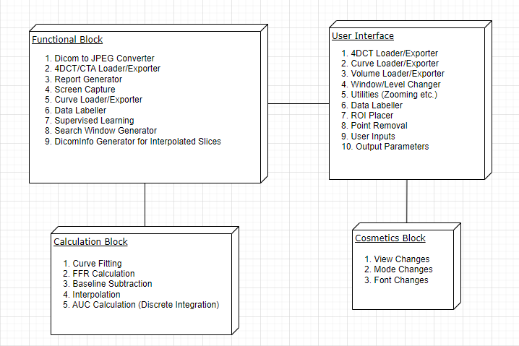

Process View

User Activities:
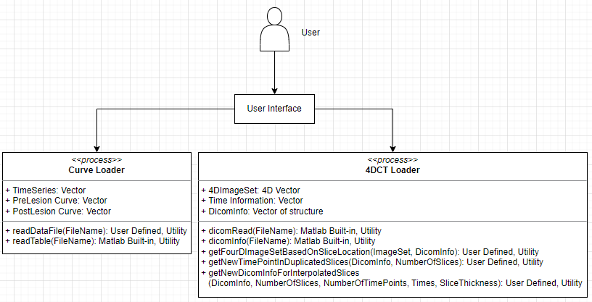

Curve Fitting Activities:

FFR Calculation Activities:

Result Export Activities:

Supervised Learning Activities:

Workflow View

Deployment View

Currently optional.

Size and Performance

Installer Size:

Installer Type | Platform Requirements | Size
Matlab Installer | Matlab Installed on OS | 1.13 MB
Windows Installer* | N/A | 2.11 MB

* This is based on DAI Vera 2.5 Build

Memory Requirements:

System Type | Memory Taken
Windows 10 | TBD
MacBook | TBD

System Compliance

DAI Vera A11.3 has been developed using the following systems:

- Matlab 2021a
- Windows 10 Home 64-bit (10.0, Build 19044)
- Intel Core i5-4570 CPU @ 3.20 GHz (4 CPUs)
DAI Vera A11.3 has been tested using the following platforms:
Platform 1:
- Matlab 2021a
- Windows 10 Home 64-bit (10.0, Build 19044)
- Intel Core i5-4570 CPU @ 3.20 GHz (4 CPUs)
Platform 2:
- Matlab 2023a
- Windows 10 Enterprise 64-bit
- Intel Core i9-12900 (24 CPUs)

Glossary

List of Input Parameters

Input | Unit
Contrast volume | mL
Contrast concentration | mg/mL
Conversion factor | HU/mg/mL
Pre-lesion tracer percentage | %
Post-lesion tracer percentage | %
Post-lesion lumen radius | cm
Aortic blood pressure | mmHg
Arterial Roughness | cm
Distance breaker | N/A
Pre-lesion point | N/A
Post-lesion point | N/A
Stenosis: Entry slice number | N/A
Stenosis: Exit slice number | N/A
Stenosis: Lumen narrowing | %
Stenosis: Entry lumen radius | cm
Stenosis: Exit lumen radius | cm
Stenosis: Entry tracer percentage | %
Stenosis: Exist tracer percentage | %

List of Output Parameters

Output | Unit
FFR | N/A
Pre-lesion flow velocity | cm/s
Post-lesion flow velocity | cm/s
Pre-lesion shear stress | Pa
Post-lesion shear stress | Pa

Definitions of terminologies

In the code, the following symbols are used instead of their full meaning and description. For example, in the following code segment the reader may find deltaP, FFR, rho, pL and so on. They are defined in the following glossary table.

Symbol | Description | Unit
F | volumetric flow rate of blood | mL/s
Q | mass of tracer | mg
C_{a}(u) | arterial concentration of tracers at time u | mg/mL
V | flow velocity of blood | cm/s
r | radius of blood vessel | cm
P | flow pressure | mmHg
ρ | density of blood | g/cm³
g | Earth’s gravity | cm/s²
h | vertical distance from a reference plane | cm
ΔP | flow pressure difference between slices A and B | Pa
P_{L} | flow pressure loss | Pa
P_{LF} | flow pressure loss due to friction | Pa
P_{LE} | flow pressure loss due to turbulence | Pa
D | diameter of blood vessel | cm
L | distance between slices A and B | cm
f | Darcy friction factor | -
Re | Reynolds number | -
ε | surface roughness | cm
μ | blood viscosity | g/cm.s
SBP | systolic blood pressure | mmHg
γ | stress rate | s⁻¹
τ | sheer dress | Pa
ν | volume of section in a blood vessel | mL
ι | length of section in a blood vessel | cm
x | maximum contrast enhancement | HU

